Butterfly Network

A butterfly network consists of (k+1)*2^{k} nodes, divided into k +1 rows or ranks, each containing n=2^{k} nodes
Example:-
Nodes =32 then (k+1)* 2^{k} = 32
4 * 8=32
(3 +1)* 2³ =32, that makes k= 3 so k+1 = 4 rows or ranks of nodes( ) .

Rank 0

Rank 1

Rank 2

Rank 3

Let nodes ( i , j ) refer to the j^{th} node in i^{th} rank
where 0 ≤ i ≤ k and 0 ≤ j ≤ n

Routing function
Node ( i , j) of rank i > 0 is connected to node ( i -1 , m) , where m is the integer formed by inverting the i^{th} bit of binary representation of j. And using same method node ( i , m) is connected to ( i – 1, j).
Say node ( 1, 0) gets connected to node ( 1-1, 100)=node( 0, 4) and
node ( 1,4 ) gets connected to node ( 1 -1, 000)= node( 0, 0)

Pictorially the above two connections look like the following butterfly pattern :

0 1 2 3 4 7
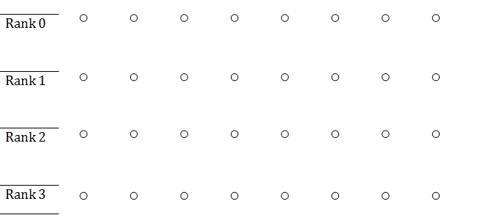

Similarly node ( 1,1) gets connected to ( 1-1 , 101)= ( 0 , 5)
and (1 , 5) gets connected to ( 1 – 1, 001 ) = ( 0 , 1 )
node ( 1,2) gets connected to ( 1-1 , 110)= ( 0 , 6)
and (1 , 6) gets connected to ( 1 – 1, 010 ) = ( 0 , 2 )
node ( 1,3) gets connected to ( 1-1 , 111)= ( 0 , 7)
and (1 , 7) gets connected to ( 1 – 1, 011 ) = ( 0 , 3 )

0 1 2 3 4 5 6 7
Rank 0

Rank 1

Rank 2

Rank 3

Taking rank 2 node ( 2,0) gets connected to ( 2-1 , 010)= ( 1 , 2)
and (2 , 2) gets connected to ( 2 – 1, 000 ) = ( 1 , 0 )
node ( 2, 1) gets connected to (2-1 , 011)= ( 1 , 3)
and (2 , 3) gets connected to ( 2 – 1, 001 ) = ( 1 , 1 )
node ( 2,4) gets connected to ( 2-1 , 110)= ( 1 , 6)
and (2 ,6) gets connected to ( 2 – 1, 100 ) = ( 1 , 4 )

Rank 0

Rank 1

Rank 2

Rank 3
Taking rank 3 node ( 3,0) gets connected to ( 3-1 , 001 )= ( 2 , 1)
and (3 , 1) gets connected to ( 3 – 1, 000 ) = ( 2 , 0 )
node ( 3, 2) gets connected to (3-1 , 011)= ( 2 , 3)
and (3 , 3) gets connected to ( 3 – 1, 010) = ( 2 , 2 )
node ( 3,4) gets connected to ( 3-1 , 101)= ( 2 , 5)
and (3 ,5) gets connected to ( 3 – 1, 100 ) = ( 2 , 4 )
node ( 3,6) gets connected to ( 3-1 , 111)= ( 2 , 7)
and (3 ,7) gets connected to ( 3 – 1, 110 ) = ( 2 , 6 )

0 1 2 3 4 5 6 7

Putting all the above three in the same diagram

0 1 2 3 4 5 6 7
Rank 0

Rank 1

Rank 2

Rank 3

As the rank number decreases the width of the wings of the butterflies increases exponentially. For this reason the length of the longest network edge increases as the number of network nodes increase.
The diameter of a butterfly network with (k+1)*2^{k} nodes is 2k
(Diameter, the maximum number of nodes through which a message must pass on its way from source to destination. Diameter measures the maximum delay in transmitting a message from one processor to another.)
Bisection width of a network of that size is 2^{k-1}
A butterfly network is used to route non-local memory to processors on BBNTC2000 multiprocessor

